Comments from associate editor

The Editorial Board of the American Naturalist has reached a decision regarding your article, "Strolling through a century: replicating historical bird surveys to explore 100 years of change in an urban bird community." Your manuscript has been evaluated by two reviewers (comments below) and by myself. After reading the manuscript and the reviews, I find that I must decline the manuscript without prejudice. Consequently, I regret to inform you that I cannot accept your manuscript for publication in the American Naturalist. Because of space limitations, we must decline many good manuscripts that are worthy of scientific publication. However, I would be willing to consider submission of a greatly revised manuscript that addresses these serious concerns raised by the reviewers and myself.

All of the readers of you manuscript were intrigued by the comparisons of bird diversity within Chicago across more than a century. Quantitative comparisons across this time scale, and particularly within urban environments, are rare and carry potential of exceptional value in understanding ecological process. That said, there are several important concerns about the manuscript in its current form that preclude publication in the American Naturalist.

The first issue has to do with the depth of analysis of the data. As Reviewer 1 points explains, there is much more that could be done with the data to address the temporal changes (or lack thereof) of different measures of diversity. Deeper explorations of these suggestions, including effect sizes, relative comparisons to regional species changes, and alternative measures of diversity would vastly improve the manuscripts impact in the ecological literature.

The second issue has to do with presentation. As written, this is a rather narrow report about a fascinating data set. By limiting the context to birds in Chicago, I think the paper misses the chance to address important ecological issues that will appeal to a broader readership. There are other long term comparisons of diversity (even of birds), as noted in the introduction. It strikes me that what makes these data especially interesting is that they address changes within an urban environment, albeit one that is changing. The introduction and discussion of the paper as it stands are written for an ornithological audience, and effectively detail which taxa increase or decrease with little reference to more general ecological ideas. Some substantial rethinking of the overall presentation is essential to make this suitable for the American Naturalist. This is, of course, up to the authors, but I would suggest an emphasis on temporal trajectories of diversity in urban environments, what we know and might expect, along with discussions of the factors that do or do not change along with species composition.

I understand if you wish to send the manuscript elsewhere, but do want to encourage you to consider the broader implications of this exciting dataset. If you choose to resubmit, please include a detailed response to reviewers explaining your responses to their comments. Your responses will be available to any reviewers.

**Thank you both for the encouragement to look further into these data and consider rethinking how we framed this paper so that we may reach the broad readership of American Naturalist. Regarding the analysis, we have improved it in a number of ways.**

1. **We have provided effect sizes regarding the frequency change of species (see Figure 2 in the updated manuscript). We certainly have these comparisons for all the species in this analysis (though they could not all fit in one figure in an interpretable way) and would be happy to include it as supplemental material if that would help.**
2. **We have added a comparison to regional changes for breeding birds throughout Illinois. Briefly, we did find that birds who increased in regional occupancy over roughly the same time period, on average, also increased in frequency throughout Lincoln Park. However, there were some exceptions to this rule. As an example, American crow have substantially increased in frequency over time in Lincoln Park but have decreased in statewide occupancy (Figure 2). We thank the reviewers and the associate editor for encouraging us to look into this further as it helps indicate how the results we have observed in Lincoln park may partly be associated to factors occurring at much larger spatial scales.**
3. **We have improved our diversity analyses in a few ways. First, we estimated species richness across survey periods using rarefaction to potentially account for species present but not observed (see LINES YYY in methods for more details). Second, we statistically compared beta diversity among survey periods using permutational ANOVA (PERMANOVA), which allows us to estimate how much variation survey period explained in terms of community composition. Survey period was a significant predictor of community composition and explained roughly 60% of the variation in the data.**

**In addition to this, the associate editor encouraged us to think more broadly about how temporal trajectories of diversity in urban environments may change. With this suggestion, we have not only broadened both our introduction and discussion to explore this concept but have also added additional variables into our analysis to potentially identify possible species traits that could be associated to species changes in frequency. Overall, we found that species with a greater diet breadth (i.e., species with more generalist diet preferences) were the species that, on average, increased in frequency throughout Lincoln Park over time. When combined with the regional scale results, this analysis helps identify how both species-specific traits as well as broad-scale factors may relate to changes in urban diversity over time.**

Reviewer #1:

General considerations.

I find the MS suitable for the journal. Authors combine old and new data regarding the effects of urbanization on the bird species richness in a large urban green space, Lincoln Park (LP), in Chicago, IL. I think the MS gives review enough papers on related subjects. I find the paper has the right length for the data and analyses at hand. Also, the prose is clear. However, regarding the figures authors use to support their points, I think they can do a better job (see me comments, below). Therefore, my overall suggestion is publish with major changes.

**We thank the reviewer for these comments and have substantially modified our manuscript based on their suggestions (see below).**

I consider this MS as an empirical paper. Authors report spatial and temporal data for their field work. And this is especially needed in this MS, taking into account the goals of the study (lines 41 ff). Authors do include some information on how sample sizes were chosen (lines 72-77) and field methods actually employed (lines 78-87).

My main concerns are related with the data analysis authors employ in order to achieve their goals. In line 97, they say that alpha diversity was computed as the number of species observed. I do not think this is the best they can do with their data. In fact, if I have understood the MS, they can compute species accumulation curves and/or obtain species richness estimators in order to consider also the present but not observed species. Authors could perform these analyses using their incidence matrices (species × date), using standard software (for instance, EstimateS; or, R, if they want). In this way, they could give more information regarding the magnitude of alpha diversity, and also the possible changes in this measure of bird diversity through time. I really encourage authors to perform these analyses.

**This is a wonderful suggestion. In the revised manuscript we have estimated species richness based on species accumulation curves during the three different survey periods. To describe this analytical approach we added the lines “” to the methods (and then of course bring up the results).**

Also, regarding how authors use their information, I do have my doubts about the possible effect (but not accounted for) on alpha diversity of differences between observers. And it is going to be very difficult to disentangle this possible effect from the temporal effect of the sampling years. In fact, in this study the possible effect of the observer is totally confounded with that from the sampling year. All the field work from 1898-1903 was completed by the Walters; all the effort between 1927-1933 was due to Dreuth, and all the most recent census work was done by one of the authors between 2012 and 2015. So, in this case, we cannot know if possible differences in alpha diversity and bird community composition are caused by real, ecological factors changing in time (for instance, urbanization), or if they are caused (partially, at least) by inter-observer bias. In fact, recent studies on bird occupancy include observer as a covariate, in order to test this effect. I suggest authors review some recent papers on this topic and consider how they can improve their analyses following these lines. Otherwise, the inferences they do in the paper (for instance, lines 215-218) regarding the negative changes in some species are very weak. And the same could (should?) be said for some (or all?) of the positive changes in species frequency through time. I mean, why only some decreases could be produced by methodological differences between surveys? I understand authors' reasoning for species like nighthawks. My point here is that methodological differences not related with species biology, but with inter-observer bias, could be producing changes in species detectability, too. And therefore in species frequency of occurrence, and finally their measure of change. Actually, I do not understand what authors mean in lines 218-221.

**This is an interesting suggestion, but unfortunately we cannot use an occupancy modeling framework to separate species occupancy from detectability with our data. In such models, a central component is to conduct repeated samples across a number of sites. With our data, we only have one site and therefore lack the statistical power to estimate something like occupancy in this class of model. We still believe that while we cannot correct for inter-observer issues in sampling, we have reason to believe the historical data was collected by accomplished birders. First, the Walter’s wrote a book on birding, and given that their species descriptions are correct it is relatively safe to assume they knew how to identify the birds of Lincoln Park. Second, while Dreuth never published their results, the people who posthumously analyzed his data attested to his keen skills as a birder (CITATION). Of course, we can attest to our skills as birders. Likewise, in our reanalysis we found that birds who increased in frequency statewide, on average, also increased in frequency in Lincoln Park, which provides additional reasoning that these data can be trusted. Finally, though we could not use an occupancy modeling framework, in our reanalysis we did use rarefaction to estimate species richness to potentially account for species present but never observed.**

Although I agree with authors (line 30-31) that long-term studies can add a lot of information to our understanding of species responses to environmental changes, if the abovementioned inter-observer effects are real, and large, then the whole idea of the MS is compromised. I suggest authors pay attention to this observation, and discuss it in their MS. Then (lines 32-33), authors identify the main idea of the study: to investigate a century of change in the urban bird community in the study area (LP). However, reading the MS (for example, lines 179-182, and then 191-196), one can know that many of the observed changes at LP do mimic changes at a larger, regional scale (IL). So, my main concern with this point is that the observed changes in the study area (LP) could be caused by changes not related to urbanization in that part of the Chicago city, but to other, environmental changes in IL state, changes that could be related, or not, to urbanization (I cannot know it!). / In order to better appreciate this point, I think authors should prepare a new table confronting changes in bird relative abundance (i.e., frequency of occurrence) at a local scale (LP) vs. changes in bird frequency at a larger scale (IL). If they have quantitative information for each species (or for a number of them), they could try a regression analysis with these variables in order to test the statistical significance of this relationship between data at a regional and local scale. Using the residuals from this analyses they could identify the species with a higher than expected, or lower than expected, response.

**This is a wonderful suggestion. In our reanalysis, we have included statewide changes in occupancy as a covariate for a subset of the species (who breed in Illinois). Overall, we found that species who increased statewide, on average, increased in frequency in Lincoln Park. Likewise, as we used a mixed-effects model that generates species specific estimates we could identify species who increased more than expected or less than expected (some of those results can be observed in the new Figure 2).**

Now, regarding species specific analyses (lines 101 ff). If I really understand what authors have done up to now, they have tested the statistical significance of temporal changes in bird frequency of occurrence. And, from this, they have classified species in one of a limited number of categories (see, for instance, Fig. 2). However, I think they should also quantify the effect-size of the change. I mean, two different species of bird (say, A and B) could monotonically increase (i.e., be classified into their group #2; line 112), and nevertheless they could reveal very different changes in frequency (for example, for species A: 10 to 13 to 15; and, for species B: 10 to 40 to 95, or any other values). Sure authors have thought about this point, but I think they have to state it in the MS, and treat it in a better way.

**This is a fair criticism to our first analytical approach. We have since dropped this categorization from the analysis and focus more heavily on discussing matters in terms of effect size instead of saying that a species increased or decreased. Likewise, we have included other potential predictors into our regression to identify if there are any species level traits that were correlated to relative increases or decreases in frequency.**

Jumping to the results section (line 129 ff), authors state the values of the Jaccard dissimilarity coefficients. However, I do not know if a difference of 0.59, or 0.45, or 0.48 is statistically significant or not. Maybe they could also use related methods in order to compute similarity (and, therefore, dissimilarity) between samples (actually, a measure of temporal β-diversity, or turnover) in EstimateS.

**While we still calculate Jaccard dissimilarity coefficients, we have added an additional analysis (PERMANOVA) to statistically compare community similarity among survey periods. Overall, we found that survey period explained 60% of the variation in the community. While we did not include an NMDS plot of this to save space, I have included it here to demonstrate that survey years are more similar survey periods, while survey periods are largely dissimilar.**

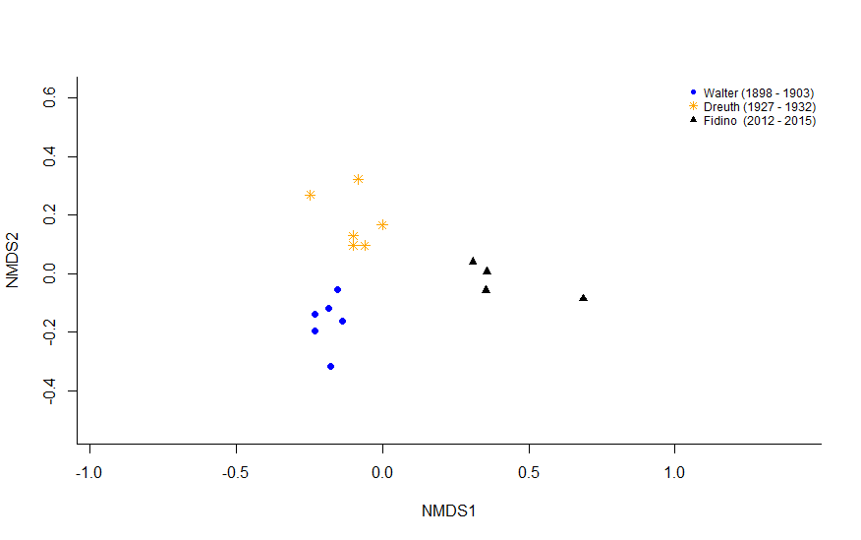

In line 143, which is the category referred to at the end?

**This has been removed in the revised manuscript**

Finally, I really encourage authors to perform the major changes suggested in this review since I find their work really important. I mean, what they say in line 226-227, that they did not see a dramatic decrease in bird species richness inhabiting their study are, despite the dramatic urbanization during most of the 20th century. If they can solve my points of concern in this review, I think this is a very good and positive conclusion, which deserves publication.

**Thank you for the encouragement.**

xxxxxxxxxxxxxxxxxxxxxxxxxxxxxxxxxxxxxxxxxxxxxxxxx

Reviewer #2:

This is an extremely well-written and engaging piece of natural history observation that also yields valuable insights into long term changes in biotic communities with urbanization. In addition, the authors appear to have brought older, somewhat buried natural history observations into the light where they can continue to be used by others. The sampling design and analysis thoughtfully and cautiously deals with the constraints of working with old data that is unaccompanied by much in the way of metadata. It is helpful that the previous sampling was done over a long period of time with records of daily observations, allowing for an estimate of total sampling effort as well as an index of abundance rather than simply presence-absence data as many previous studies revisiting old data are forced to do. The conclusions are properly cautious about making inferences about causality (for the most part). The discussion places the trends in a regional context by referencing statewide trends.

**Thank you.**

I have just a few minor comments:

1. It would be helpful to have a supplementary table with the population trends from the study compared to statewide trends and indicating which species are of regional or national conservation concern.

**This is also similar to a comment from the first reviewer. Instead of including a supplemental table we have instead included statewide trends in occupancy into the analysis, which provides some much needed and broader context to interpret the results that we found.**

1. Line 206 - Insert just a bit more caution in this inference by changing to "blackbird's adaptive capacity seems to have helped it..."

**This paragraph was removed from the discussion as we tried to focus more on broader concepts instead of species-specific interpretations.**

1. Line 213 - Would be more specific to say "100 years of urban intensification" since I think there was already a city present around Lincoln Park in 1898. In addition, it would be nice to have some more detailed information about the nature of urban intensification around Lincoln Park over the study period. What was the land cover like in the earliest sampling period - estimates of building density, amount of open space, etc. This is probably beyond the scope of the article, but perhaps an older map could be included as supplementary material?

**We tried to identify old data on building density and other attributes in Lincoln Park, but unfortunately could not find anything that went back as far as the historical bird data. Likewise, while there are historical maps of the park itself, all of them do not include any information urban intensity around the park. Finally, as we cannot especially relate the amount of urban intensification, and bring this up as a caveat in the discussion in multiple places (LINES ), we feel that this request is outside the scope of the manuscript. We do, however, like the reviewers suggestion that we modify of use of urbanization throughout the manuscript and instead use “urban intensification” or “urban intensity,” depending on the sentence.**

1. Line 230 - missing word at the end of the sentence - "on our rapidly changing [what?]."

**Looks like we were missing “world” in that sentence, thank you for bringing it to our attention, it has since been fixed in the revised manuscript.**